**LAB 2. Single Row Functions**

**1. Display name and date of birth of students where date of birth must be displayed in**

**the format similar to “January, 12 1981” for those who were born on Saturday or**

**Sunday.**

SELECT STUDENT_NAME,TO_CHAR(STUDENT_DOB,'MONTH,DD,YYYY') "STUDENT DOB" FROM STUDENT_MASTER WHERE TRIM(UPPER(TO_CHAR(STUDENT_DOB,'DAY'))) IN ('SATURDAY','SUNDAY');

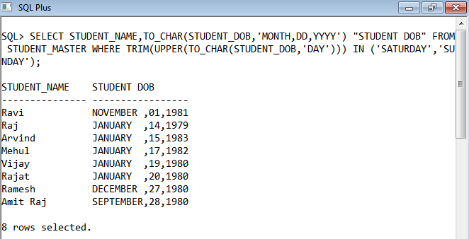

**2. Display each staff name and number of months they worked for the organization.**

**Label the column as ‘Months Worked’. Order your result by number of months**

**employed. Round the number of months to closest whole number.**

SELECT STAFF_NAME,ROUND(MONTHS_BETWEEN(SYSDATE,HIREDATE)) "MONTHS WORKED" FROM STAFF_MASTER ORDER BY MONTHS_BETWEEN(SYSDATE,HIREDATE);

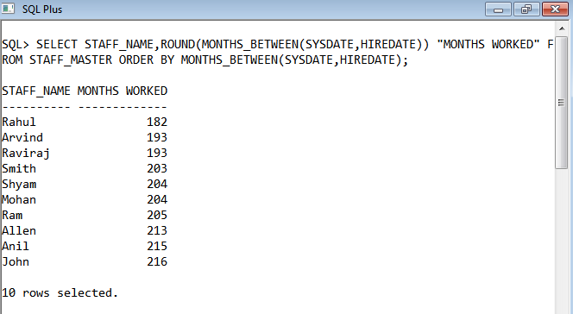

**3. List the details of the employees, whose names start with ‘A’ and end with ‘S’.**

SELECT STAFF_NAME FROM STAFF_MASTER WHERE UPPER(STAFF_NAME) LIKE UPPER('A%S');

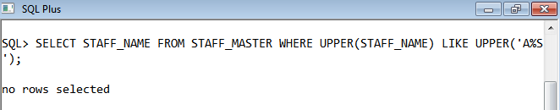

**4. List the name and job of the employees whose names should contain N as the**

**second or third character, and ending with either ‘N’ or ‘S’.**

SELECT ENAME,JOB FROM EMP WHERE (UPPER(ENAME) LIKE '_N%' OR UPPER(ENAME) LIKE '__N%') AND (UPPER(ENAME) LIKE '%N' OR UPPER(ENAME) LIKE '%S');

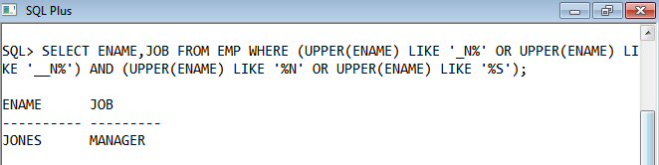

**5. Create a query which will display Staff Name, Salary of each staff. Format the**

**salary to be 15 character long and left padded with ‘$’.**

SELECT STAFF_NAME,LPAD(STAFF_SAL,15,'$') FROM STAFF_MASTER;

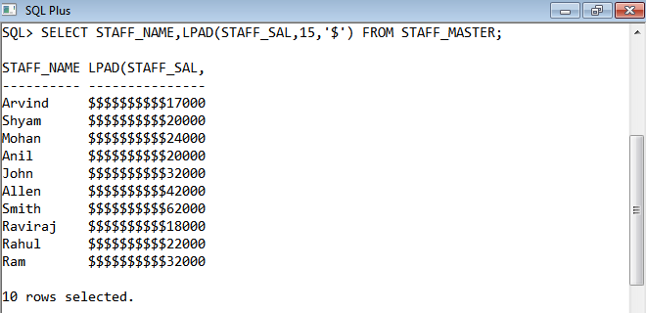

**6. List the names of the Employees having ‘_’ character in their name.**

SELECT STAFF_NAME FROM STAFF_MASTER WHERE STAFF_NAME LIKE '%\_%' ESCAPE '\';

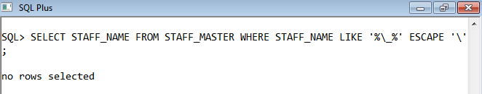

**7. List the details of the employees who have joined in December (irrespective of the**

**year).**

SELECT * FROM STAFF_MASTER WHERE SUBSTR(TO_CHAR(HIREDATE,'DD/MM/YYYY'),4,2)=12;

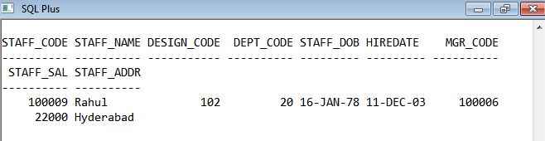

**8. Write a query that displays Staff Name, Salary, and Grade of all staff. Grade**

**depends on the following table.**

Salary Grade

Salary >=50000 A

Salary >= 25000 < 50000 B

Salary>=10000 < 25000 C

OTHERS D

SELECT STAFF_NAME,STAFF_SAL,CASE WHEN STAFF_SAL>=50000 THEN 'A' WHEN STAFF_SAL>=25000 THEN 'B' WHEN STAFF_SAL >=1000 THEN 'C' ELSE 'D' END AS "GRADE" FROM STAFF_MASTER;

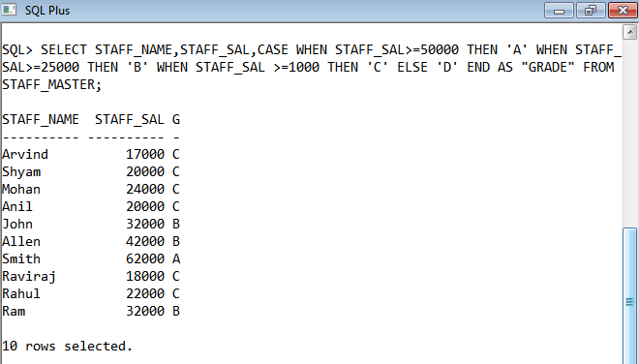

**9. Display the Staff Name, Hire date and day of the week on which staff was hired.**

**Label the column as DAY. Order the result by the day of the week starting with**

**Monday.**

SELECT STAFF_NAME,HIREDATE,TO_CHAR(HIREDATE,'DAY') AS "DAY" FROM STAFF_MASTER ORDER BY TO_CHAR(HIREDATE-1,'D');

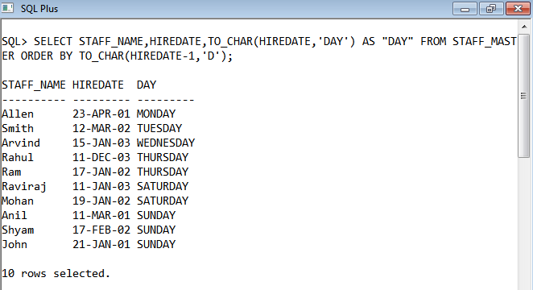

**10. Show staff names with the respective numbers of asterisk from Staff table.**

SELECT RPAD('*',LENGTH(STAFF_NAME),'*')STAFF_NAME FROM STAFF_MASTER;

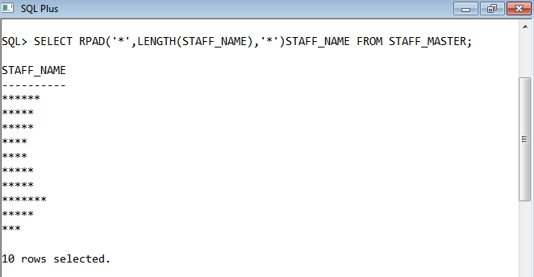

**11. Show staff names with the respective numbers of asterisk from Staff table except**

**first and last characters. For example: KING will be replaced with K**G.**

SELECT CONCAT(RPAD(SUBSTR(STAFF_NAME,1,1),LENGTH(STAFF_NAME)-1,'*'),SUBSTR(STAFF_NAME,-1,1))STAFF_NAME FROM STAFF_MASTER;

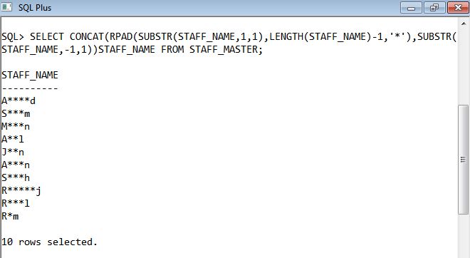

**12. Show all staffs who were hired in the first half of the month.**

SELECT * FROM STAFF_MASTER WHERE SUBSTR(TO_CHAR(HIREDATE,'DD/MM/YYYY'),4,2)=01;

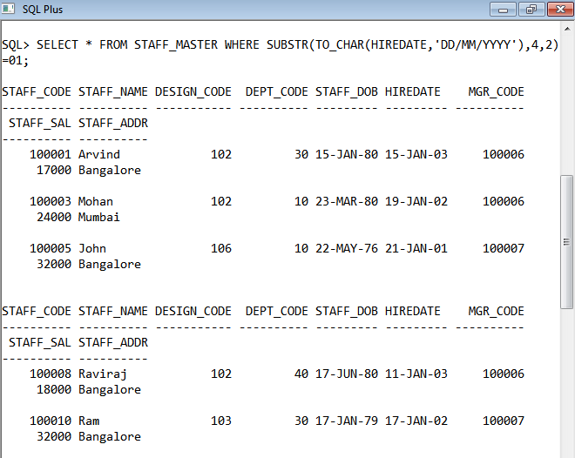

**13. Display the staff name, hire date and day of the week on which the staff joined.**

**Order the results by the day of the week starting with Monday.**

SELECT STAFF_NAME,HIREDATE,TO_CHAR(HIREDATE,'DAY') FROM STAFF_MASTER ORDER BY TO_CHAR(HIREDATE-1,'D');

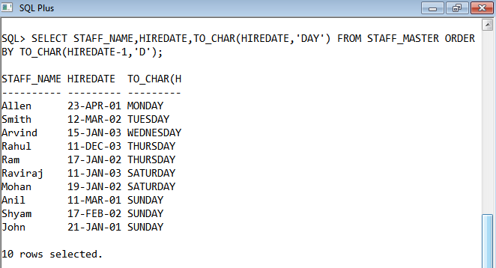

**14. Write a query to find the position of third occurrence of ‘i’ in the given word**

**‘Mississippi’.**

SELECT INSTR('MISSISSIPPI','I',1,3) FROM DUAL;

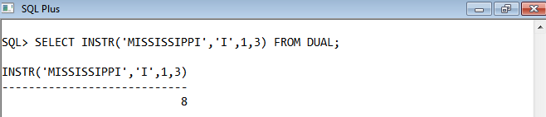

**15. Write a query to find the pay date for the month. Pay date is the last Friday of the**

**month. Display the date in the format “Twenty Eighth of January, 2002”. Label the**

**heading as PAY DATE.**

SELECT STAFF_NAME,TO_CHAR(NEXT_DAY(LAST_DAY(HIREDATE)-7,'FRIDAY'),'DDSPTH" OF "MONTH,YYYY') AS "PAY DATE" FROM STAFF_MASTER;

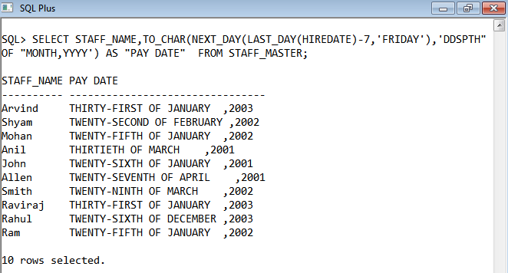

**16. Display the Highest, Lowest, Total & Average salary of all staff. Label the columns**

**Maximum, Minimum, Total and Average respectively. Round the result to nearest**

**whole number.**

SELECT ROUND(MAX(STAFF_SAL))"MAXIMUM",ROUND(MIN(STAFF_SAL))"MINIMUM",ROUND(SUM(STAFF_SAL))"TOTAL",ROUND(AVG(STAFF_SAL))"AVERAGE" FROM STAFF_MASTER;

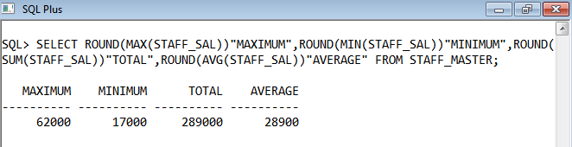

**17. Edit the above query and display the same for each Department Name.**

SELECT DEPT_CODE,ROUND(MAX(STAFF_SAL))"MAXIMUM",ROUND(MIN(STAFF_SAL))"MINIMUM",ROUND(SUM(STAFF_SAL))"TOTAL",ROUND(AVG(STAFF_SAL))"AVERAGE" FROM STAFF_MASTER GROUP BY DEPT_CODE ORDER BY DEPT_CODE;

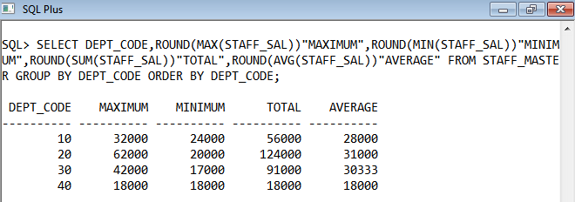

**18. Write a query to display number of people in each Department. Output should**

**display Department Code, Department Name and Number of People.**

SELECT DEPTNO,COUNT(DEPTNO) AS "NUMBER OF PEOPLE" FROM EMP GROUP BY DEPTNO;

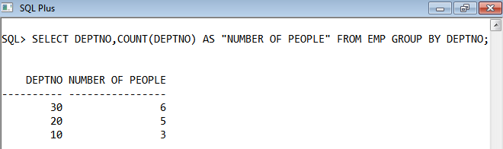

**19. Determine the number of managers without listing them. Label the column as**

**‘Total Number of Managers’.**

SELECT COUNT(JOB) AS "TOTAL NUMBER OF MANAGERS" FROM EMP WHERE JOB='MANAGER';

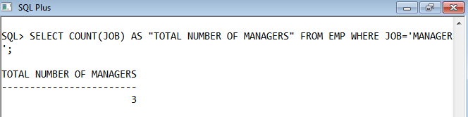

**20. Display Manager Code, Manager Name and salary of lowest paid staff in that**

**manager’s team. Exclude any group where minimum salary is less than 10000. Order**

**the result on descending order of salary.**

SELECT F.MGR,S.ENAME,MIN(F.SAL)"MINIMUM_SALARY" FROM EMP F,EMP S WHERE F.MGR=S.EMPNO GROUP BY F.MGR,S.ENAME HAVING MIN(F.SAL) > 1000 ORDER BY MIN(F.SAL) DESC;

